**PROFILE OF THE COMPANY**

There are numerous players are giving e-wallet administrations to the clients, for example, Google Pay, Paytm, FreeCharge, Payal, Banking Mobile Wallet Applications, PhonePe, PayUMoney and MobiKwik are not many renowned computerized wallet specialist co-ops to clients in India. Further, e-wallets will assist with destroying the actual touch during pandemic circumstances and kills the significance of visiting part of bank to move or transmit the cash from the financial balance during lockdown period.

**GOOGLE PAY**

Google Pay otherwise called G Pay or Pay with Google it is likewise one kind of Digital Wallet and online installment framework created by Google. The administrations of Android Pay and Google wallet converged in January 2018 and the name was changed to Google Pay. On September 2017, Google sent off a UPI-based application known as TEZ in India which was later rebranded as Google Pay. Google pay has in excess of 25 million dynamic clients in a month of the computerized wallets in India. Google pay exchanges are free from any potential harm.

Google Pay empowers you to: -

* Send and get cash.
* Store your credit/check card data safe.
* What's more, utilize this data to pay for different things on different applications.

Google Pay is known for its security among other comparative computerized installment applications. Google store your credit/charge card data in its protected servers utilizing solid encryption. Distributed storage and information security of the clients is the great worry of Google.

Google combined efforts with regulators and the portions climate to ship off Google Pay. This helped drive and scale UPI use through the Google with paying application, which at this point has 67 multi month to month unique clients. Google Pay has enabled more than 2.5 billion trades, and as of now has a yearly run speed of over US$110 billion in return regard. This droves not just fundamental portion organizations like companion to-interminably ally to-seller, yet it moreover made room to regard added organizations like second credits. More than $110B in return regard travels through Google Pay in India Monthly Active Users $110B Total Payment Value: Annualized Run Rate 67M $ TPV ARR Since ship off, we've been working with an extent of accessories, from transporters to tremendous banks, to work out new components that drive improvement and money related joining. With Google Pay, we need to ensure there are anything that number spots as could reasonably be expected for clients to pay. In India, we've worked actually with enormous and little dealers. Google Pay clients can now pay at in excess of 200,000 stores in excess of 3,500 metropolitan areas and towns, and in excess of 2,700 web-based dealers. Considering UPI interoperability, the veritable number of shippers that perceive Google Pay is fundamentally higher - more than 1.2 million exclusive organizations use it. Going on, we at Google Pay are looking at the way we can go past segments to help SMBs make and speed up monetary breaker for clients. We've carried out a committed dealer experience with a prize’s framework, assisting them with speaking with their clients through messages and offers. We've additionally sent off the Spot Platform, a computerized customer facing facade on Google Pay that permits shippers, everything being equal, to make, brand, and host anyway they pick, making them discoverable online as well as through an actual spot. What's more, we're working with banks to interface with their clients in new ways and proposition preapproved moment credits inside Google Pay, without the requirement for extra reports.

**PAYTM:**

PayTM is an Indian web-based business administrator and Financial Technology organization. Paytm was established in August 2010 by its originator Mr. Vijay Shekhar Sharma. In 2014, the organization sent off its first Digital E-wallet known as Paytm Wallet. Paytm offers Digital wallet installment, versatile installments, web-based shopping, Paytm Payments Bank and so forth In the year 2015, RBI gave License to Paytm to send off Paytm Payments Bank which was subsequently initiated in the year 2017 by the then Finance Minister Mr. Arun Jaitley. Paytm works in 2 distinct ways:- Paytm Wallet and Paytm Payments Bank. Paytm is known as an advanced installment framework which permits you to move cash through your charge/Mastercards and which additionally permits you to do internet banking. When you register to Paytm you can create online installment of bills or you can make installment through you paytm wallet by first adding cash into your wallet.

**PHONEPE:**

PhonePe or PhonePe Private Limited it is an Indian web-based business installment administration and advanced wallet organization. PhonePe was established in the year 2015 by its originators, Mr.Sameer Nigam and Rahul Chari and it was the first installment application in Quite a while which was based on Unified Payments Interface i.e (UPI). PhonePe is currently accessible in 11 Languages. Telephone Pe offers different administrations, for example, -

* User can send or get cash through Phone Pe application.
* User can make different installment versatile re-energizes, DTH re-energizes, clients can likewise make installments of shopping on the web on different applications.
* Phone Pe even permits clients to book tickets through different applications, for example, Redbus, Goibibo, Ola and so forth Telephone Pe application has in excess of 100 million clients and it has crossed in excess of 5 billion exchanges. Most recent advancement of Phone Pe application is that it permits its clients to pull out cash through its in-application UPI include which is otherwise called Phone Pe ATM, and that implies that moving the said sum which must be removed to a close by Phone Pe empowered shipper/vender.

**MOBIKWIK:**

MobiKwik is additionally another Indian organization application which goes about as an advanced wallet, as a portable installments framework. MobiKwik is an application established by Bipin Singh and Upasana Taku in the year 2009. At first MobiKwik was only a site with shut wallet office yet later began with portable applications. In the year 2016 MobiKwik sent off - Mobikwik Lite application which was for more seasoned 2G versatile organizations and those with unfortunate organization network. MobiKwik sent off its very first Mobile Wallet framework in the year 2012. Mobikwik additionally sent off the component of sending and getting cash through a versatile application. Mobikwik additionally offers monetary types of assistance, for example, giving advances, different protections like life coverage, mishap protection, fire protection as well as shared reserves. In the year 2017, MobiKwik „s greatest contender was Paytm. As per Forbes India Magazine, in the year 2015 MobiKwik was involved by more than 15million clients for its interesting highlights and was likewise guaranteeing of increment of 1,000,000 clients consistently. In the year 2016, India had Demonetization during this time Mobikwik had a 400% expansion in Financial Transactions.

**YONO by SBI:**

This versatile wallet application was presented by State Bank of India. This wallet offers its associations in 13 Languages. The word YONO surmises You Only Need One, this application assists clients with getting to different monetary and different associations, it goes most likely as a Digital Banking stage which offers different associations, for example, electronic shopping segments, booking tickets of (train, transport, taxi, flights), it besides permits clients to make expert's visit cost segments. YONO application was delivered off in the year 2017 by Mr. Arun Jaitley, the Finance Minister of India. This application can besides be utilized by clients to make ATM withdrawals too as this application can be utilized to make different asset moves, and so on Through YONO application a client can follow his/her OD account balance, could open fixed store, repeating stores, and would truth be able to be informed put resources into shared saves. Clients could truly follow their advances through this application.

**CITI MASTERPASS:**

CITI MasterPass was shipped off by Citi Bank India and Mastercard. It is India‟s first overall Digital wallet. Citi MasterPass safely stores the privileged information i.e the data of client’s card and their conveyance information is taken care of in their mastercard. So while making the portion the client basically needs to pick the decision of „Buy with MasterPass‟ as the portion decision while checkout, by doing this the cutomers need not have to fill in all of the nuances. By this incorporate the bet of clients arranged information can be uncovered, as client are by and large requiring safeguarded, secure, essential and quick trades while shopping. CITI MasterPass is accessible more than 24 countries all over the planet. In today‟s world around 41 % exchanges of Citi Bank are performed through online mode due to its solid, security and imaginative associations.

**UPI BHIM APP:**

BHIM represents Bharat Interface for Money. BHIM App is created by National Payments Corporation of India i.e (NPCI) and it depends on Unifies Payment Interface i.e (UPI). Our Prime Minister Shri Narendra Modii had sent off this application. BHIM App was sent off on 30th December 2016 and is as of now accessible in 20 dialects. BHIM App acknowledges all Indian banks which chips away at UPI framework and which is worked over IMPS i.e Immediate Payment System which permits the client to move cash to Bank records of any two gatherings. Involving UPI framework client can make exchanges in a simple, fast and basic way. Through BHIM App clients can do the different administrations: -

* User can Send cash.
* User can Request cash, for this it is obligatory that the client's versatile number be connected with the ledger utilizing.
* For fast exchanges clients can Scan and Pay.
* Additional component of BHIM App is that it permits the clients to actually look at their exchange’s history.
* There is a report tab in BHIM App for the clients on the off chance that they have any grievance to raise, they can utilize this tab to do likewise.
* Next choice in the BHIM App is the Bank account choice, so through this choice client can see the financial balance that is connected with his/her BHIM App. A client can likewise change the financial balance simply by clicking „Change Account‟ in the BHIM App.

**HDFC PAYZAPP:**

PAYZAPP is a versatile portion application made by HDFC Bank. Payzapp licenses clients to recharge their phones DTH recharges as well, cover administration bills, for instance, power bill, etc, clients can buy film, train, flight tickets, book a taxi and can similarly shop on the web. Clients can similarly send money to their friends and family and can moreover follow their expenses. Client necessities to associate their record with HDFC PAYZAPP application to participate in the most solid strategy for portion. You want to just channel a QR Code to make any portion in Payzapp application. During the farewell of Payzapp application, Aditya Puri the Managing Director of HDFC Bank said "The wallet we introduced under Payzapp, as opposed to various wallets, is everything except a prepaid wallet. It reflects your record and it reflects your Visa balance. Even more fundamentally it is a solitary tick. That is the solace." How in any case Payzapp App? -

1. First you need to download the Payzapp application from Playstore.
2. Enter your enlisted portable number i.e the versatile number which is enrolled with your ledger.
3. Complete the enlistment cycle by perusing all the KYC steps.
4. The in the following stage you need to connect you ledger or your Visa with the Payzapp application.
5. You are prepared to utilize Payzapp application.

**IMPACT OF COVID-19 ON THE PAYMENTS INDUSTRY**

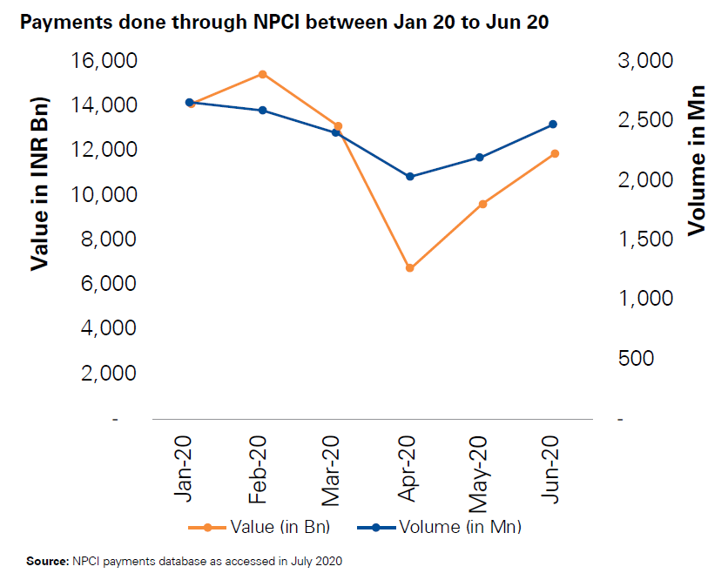Payments done through NPCI

UPI, BHIM and IMPS

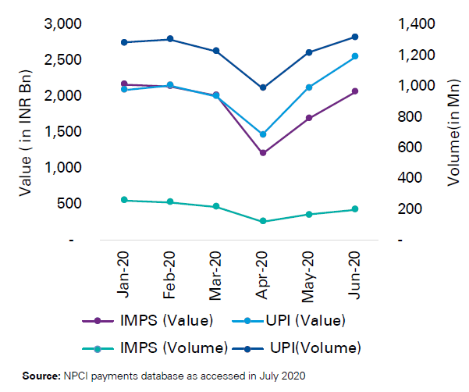

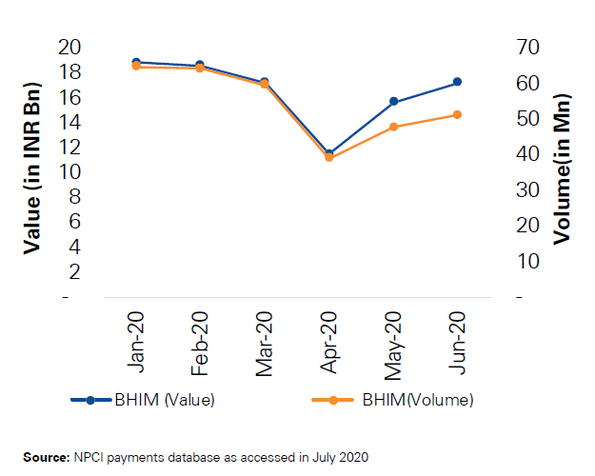

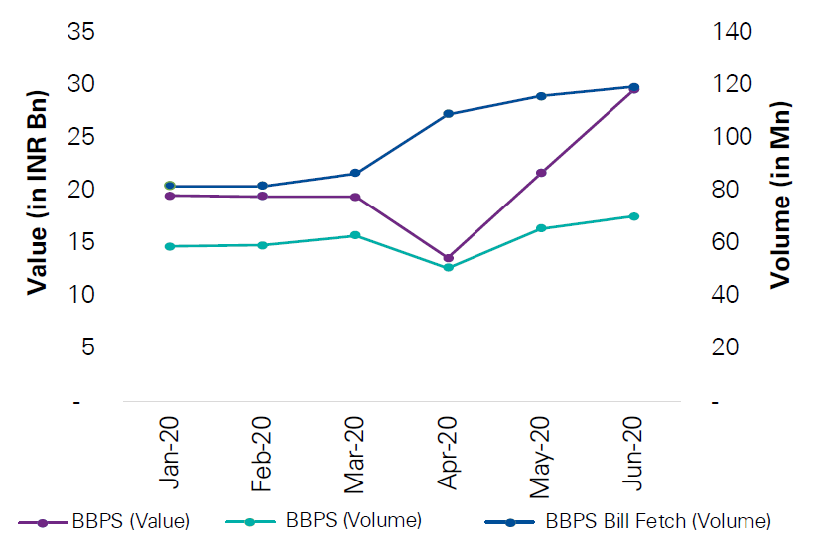Bharat Bill Payment System (BBPS)

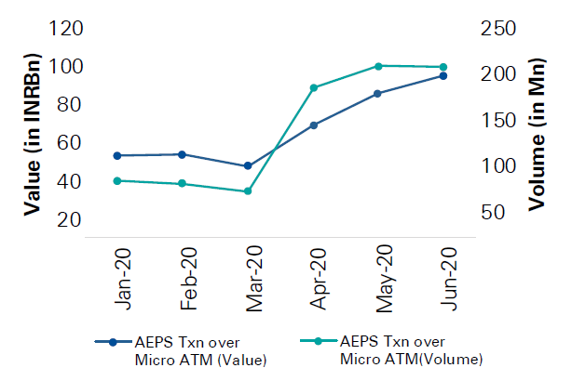AePS Transactions over Micro ATMs

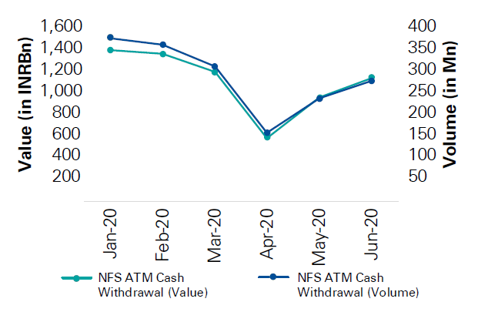National Financial Switch (NFS) Cash Withdrawals

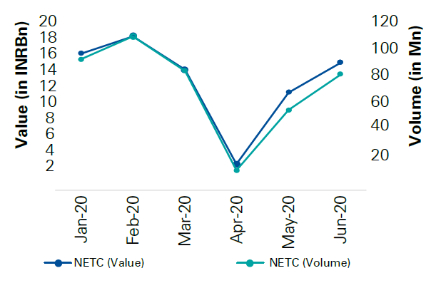National Electronic Toll Collection (NETC)

**CYBERSECURITY**

To further develop client trust in computerized installments, it is of most extreme significance to keep a control on the quantity of cheats that happen, and to guarantee that clients are not affected. Advanced cheats and wrongdoings are supposed to be a tireless point in future installment, particularly as the worldwide pandemic is considered in the situation. Adjusting client experience with digital protection is a continuous test in the monetary business, and advancement in misrepresentation avoidance is a significant center that is supposed to go on before very long. Personality shams are developing, and hoodlums are involving taken ID as well as making new, advanced just characters by weaving together genuine and imaginary data. These 'engineered personalities' exist just in the advanced framework. Existing misrepresentation recognition models are intended to forestall exchange extortion and can't address these dangers. Banks and installment organizations should push to out-enhance fraudsters. Some are utilizing new advancements, for example, geolocation, acoustic investigation and information examination based recognizable proof of strange occasions for computerized applications and on the web, versatile and call focus overhauling channels.

Considering such developing false duplicities, Artificial insight is supposed to become fundamental for effective installments extortion counteraction techniques. As India's reliance on computerized installment frameworks extends, especially through the UPI and versatile wallets, these weaknesses are growing the danger scene for digital assaults, for example, mocking of personalities, meeting capturing, malware infusion, 'Circulated Denial of Service' and 'Man in the Middle' assaults.

**POTENTIAL GROWTH IN PAYMENTS INFRASTRUCTURE**

In spite of the present moment and medium-term effect of COVID-19 on the economy and the advanced installments space, the drawn-out possibilities for the business are promising and volumes are supposed to proceed with development energy.

To help the development, the public authority is taking a few drives, including:

**NCMC: -** the Ministry of Urban Development has delivered the public normal portability card (NCMC) rules (in light of open circle RuPay Contactless particulars) with the vision to have a cross country normal versatility card that is supposed to work across all open circle installment framework.

**Installment Infrastructure Development Fund (PIDF): -** a bank and other installment delegates supported advancement reserve with commitments from the controllers to further develop installment framework. PIDF ought to be utilized to assist the acknowledgment foundation across Indian unassuming communities and towns. Additionally, given the circumstance, the push on installments foundation should be on contactless installments from the begin to increment agreeableness.